LAB 4

Exercise 1 — Person and Student
File: PersonDemo.java
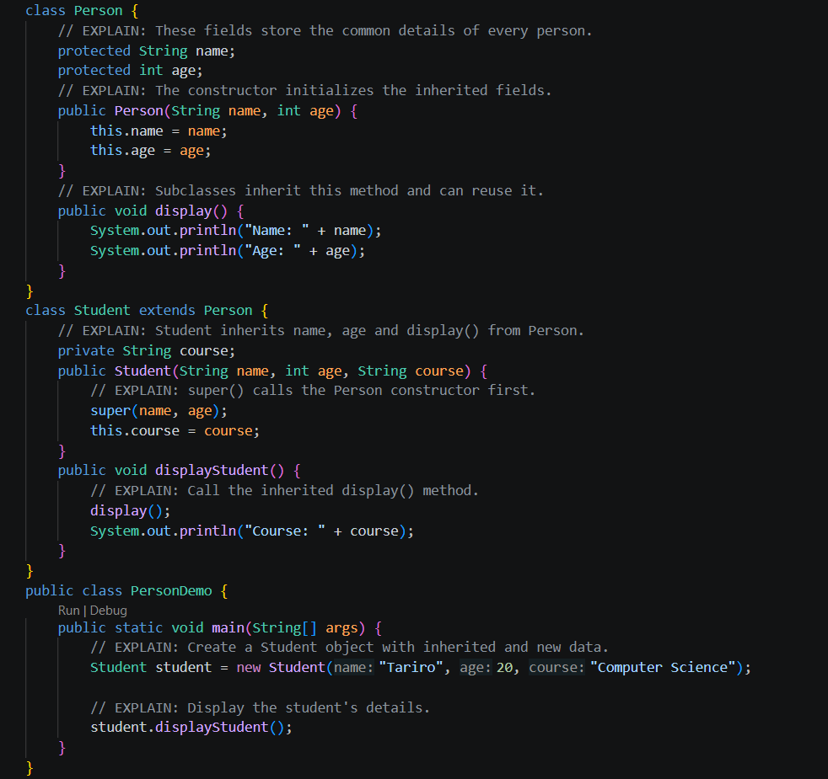
Output:
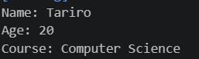

Exercise 2 — Add a Teacher subclass
File: InheritanceDemo.java
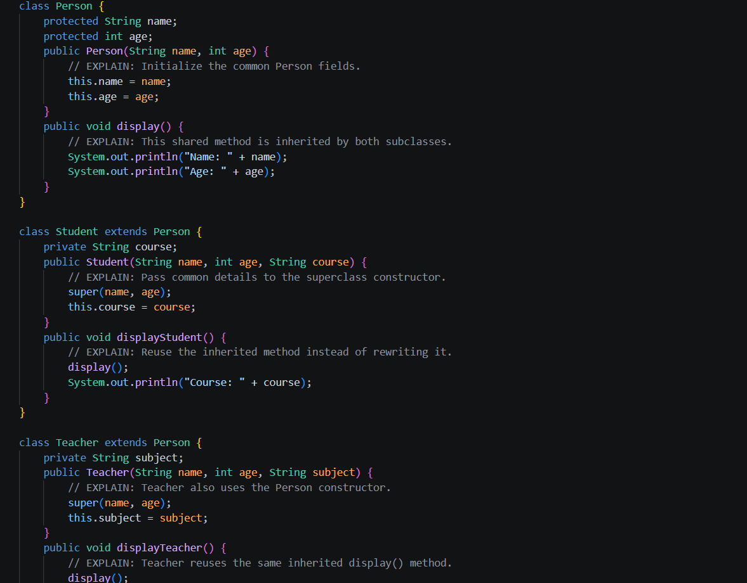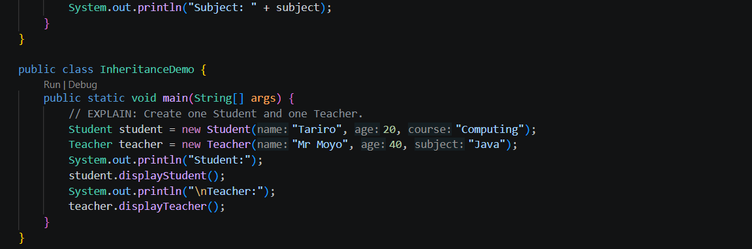
Output:
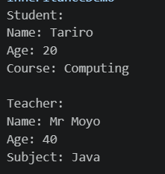

Exercise 3 — Multilevel inheritance and constructor order
File: VehicleDemo.java
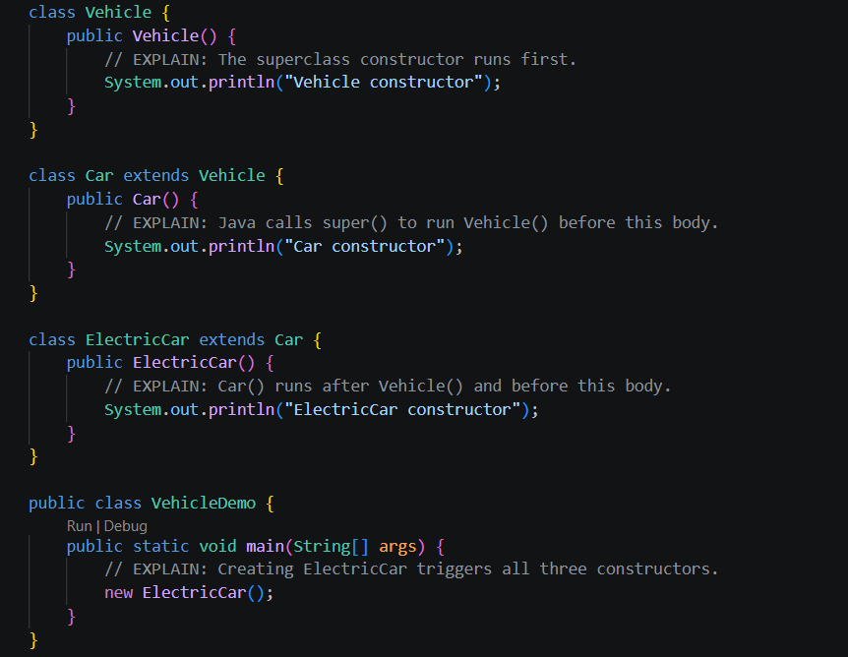

Output:
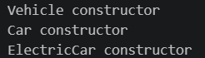

Exercise 4 — Why Dog extends Animal fails
File: InheritanceConstructorDemo.java
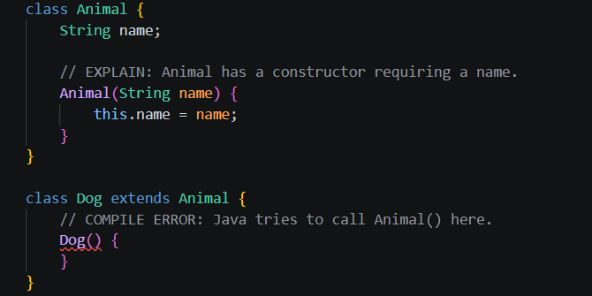
Corrected version:
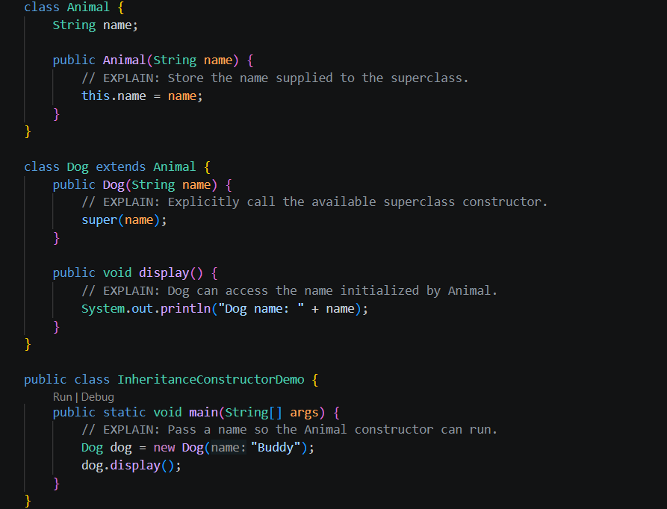
Output:
Looking at the 2 codes one with error and the corrected version. The first code fails to compile because Java attempts to call Animal() automatically, but only Animal(String name) exists.

Exercise 5 — Refactor Stack extends ArrayList into composition
File: StackDemo.java
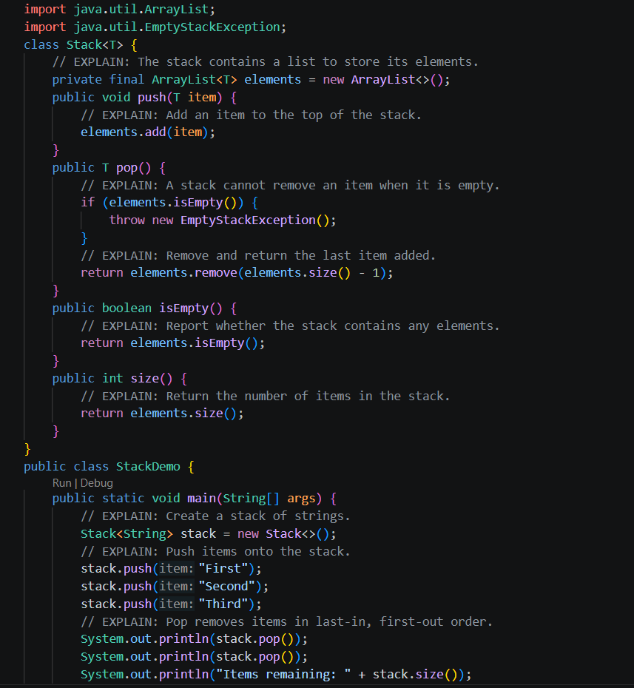
Output:
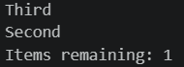
What the inheritance version wrongly exposes: If Stack extends ArrayList, callers can use list operations such as add(index, item), remove(index), and other methods that bypass the stack's intended push/pop-only behaviour. Composition hides the internal list and exposes only the operations chosen for the stack.

